**Rabbit welfare charity wins fight to stop plans for breeding unit**

By [Charlotte Jones](http://www.lincolnshirelive.co.uk/people/Charlotte%20Jones/profile.html)  |  Posted: February 05, 2017

image: http://www.lincolnshirelive.co.uk/images/localworld/ugc-images/276392/Article/images/30112788/15839259-large.jpg

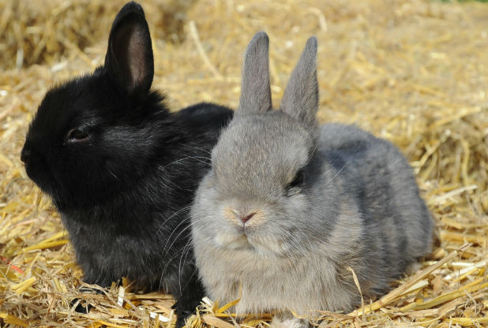

**The planning application has been refused.**

A rabbit welfare charity says it's thrilled after plans to build a [rabbit breeding uni](http://www.lincolnshirelive.co.uk/almost-50-000-sign-petition-against-pet-breeding-unit-in-lincolnshire/story-30100348-detail/story.html#SAcxO7P61hBesspJ.99)t in Lincolnshire have been rejected.

The Rabbit Welfare Association and Fund spent hundreds of pounds seeking expert advice to put together a watertight case against the application.

An online petition opposing the plans gained 31,237 UK signatures and 84,610 signatures overall.

The planning application was submitted to South Holland District Council by Glen Bruce, who currently runs a pet breeding business with his brother in the Crowland area.

[by Taboola](http://popup.taboola.com/en/?template=colorbox&utm_source=northcliffe-lincolnshireecho&utm_medium=referral&utm_content=thumbnails-d:Mid%20Article%20Thumbnails:)