31st March 2020
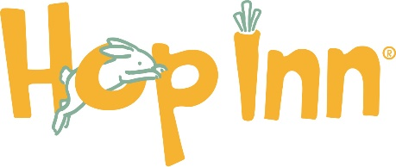 NEWSLETTER
Well, It goes without saying, we are in unprecedented times!
I hope you’re all managing to keep busy or just relaxed and happy.
Stay safe…
- PLEASE let me know if you wish to be removed from my email Newsletter – I thought best to ask!
HOLIDAYS for the Buns & Guinea Pigs
I know many of you have booked holidays throughout the year. Fingers crossed we can all get back to some sort of normality, in the not too distant future, and have a proper holiday. I’ll keep diary dates the same and just use ‘common sense’ as we bob along…

FREE DELIVERIES

I’m doing deliveries if you’re short of Hay or fancy Fresh Forage too. I’m also doing a reduction in price on our Hideouts, just for Jolibobbers of Hop Inn – NOT that they’re essential, but if I’m delivering hay & forage it makes sense to offer!

MEADOW HAY

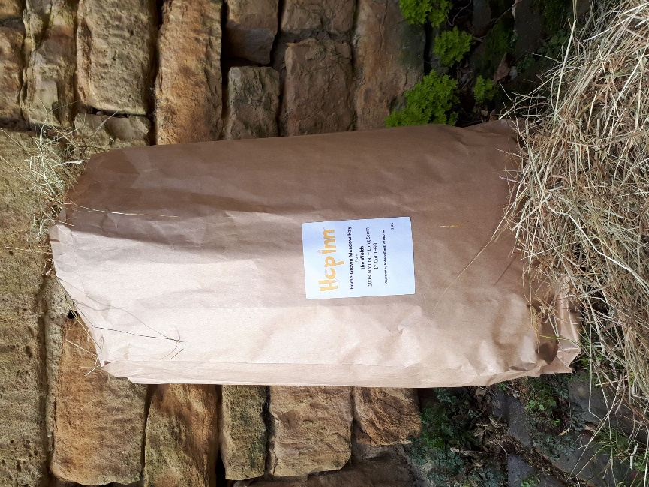
Our Own Meadow Hay – Long Stem – 1st Cut 2019 (best cut!)
We were very lucky last year to have grown our own Meadow Hay. It’s 100% natural - the fuss pot I am.
We now have rather a lot being stored, and it’s a shame to hang on to it all when I don’t have any Guests. I do get through rather a lot - ordinarily!
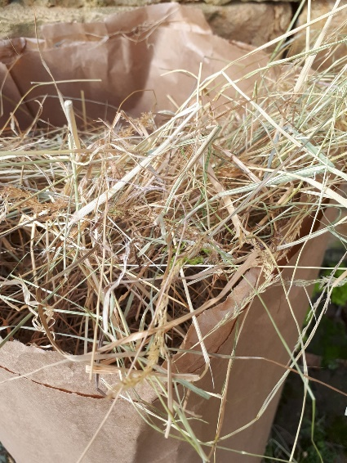
I’ll pick and pack with the protection of gloves and mask and follow the same protection when making delivers.
I understand it’s still Best practice to wash hands thoroughly after touching post etc.
.
1 Kg - £4/Bag
NEWSPAPERS
I have rather a lot of Newspapers, all kindly donated Locally. I normally use newspapers to line the bottom of the hutches & litter trays for the rabbits. If you need any with an order, please let me know. I can drop off a small pile with an order.

FORAGE
Freshly picked for Rabbits & Guinea Pigs 100% Natural Goodness….
(I’m afraid I can only deliver Forage with Hay, unless you live in or near Melton Mowbray)

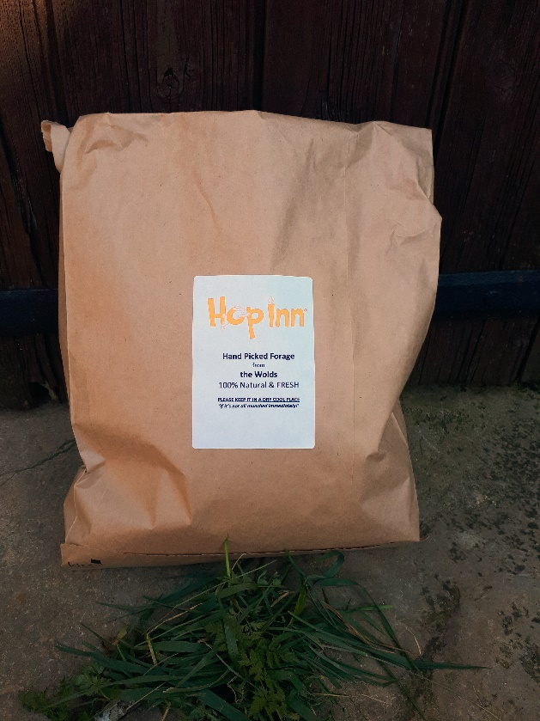
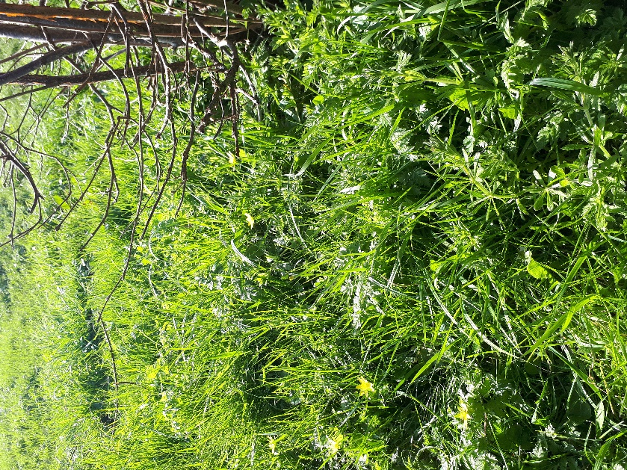

All sorts of goodies in a bag including apple twigs and/or hazel twigs

£1/Bag

Meadow Hay & Forage - £5 including delivery.

‘Hop Inn’ Hideouts for Rabbits & Guinea Pigs
Ready Made & Built to Last
NOT A Priority - but I’m not convinced everyone knows my brother hand-makes them, along with the help of my sister-in-law. Sadly, I forgot to have a Review page of these on my website, however I’m pleased to report there are raving Reviews on Amazon. I use the Hideouts all the time, indoor & outdoor for all my own furry friends & Guests at Hop Inn.
- The only time I wouldn’t recommend the rabbit hideout is if your rabbit is unsteady on their feet, due to old age or has arthritis, and compromised on their feet. The lip on the bottom of the circle can be a nuisance for them to get over.

Rabbit Hideout - £29 (RRP £33.00) Guinea Pig Hideout - £16 (RRP £21.00)

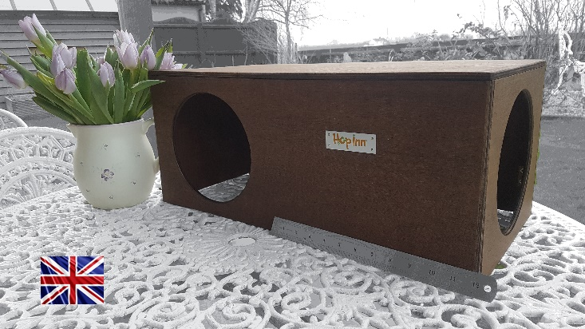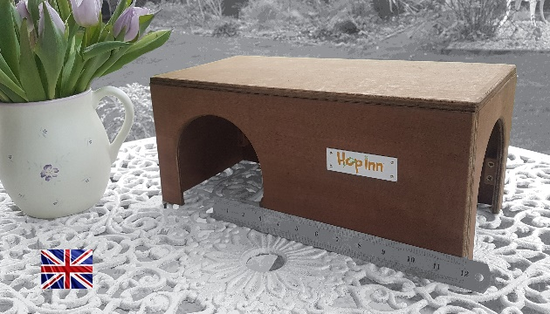

The Hop Inn Cube - £25 (RRP £33.95)
We’ve decided not to make these Cubes currently. They’ve been great but can be too high for somebunnies and not for others! Cats really enjoy the Cube Hideout. We have used one as a side table!

To just have a browse for pictures on my website http://hop-inn.co.uk/pet-play-toys/

TO ORDER:
All you need to do is reply to this email lisa@hop-inn.co.uk and I can sort from there.
I plan to carry on delivering to Areas on the days listed below:
MONDAY – Oakhan
TUESDAY – Melton Mowbray
WEDNESDAY – Grantham
THURSDAY – Leicester N/E
FRIDAY – Notts – S/E
- Boring Bit! - Payment would be Bank Transfer or Paypal

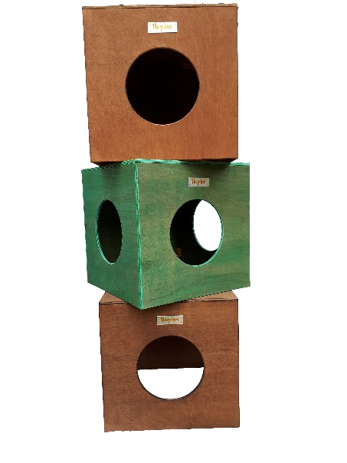
I have a limited amount of cubes …..

